**LEBANESE AMERICAN UNIVERSITY**

**USAID – HIGHER EDUCATION SCHOLARSHIP PROGRAM**

**HES - Volunteering Program Verification Form**

This form is to be used to document volunteering hours. If a student volunteers for multiple organizations, a separate form must be used for each organization. **This form must be turned in by the 28th of each month, the latest.**

I certify that the scholar Osama Ahmad Sweidan completed a total of 5 hours of service at InnovaThrive.

The hours were completed hours as per the below:

Hours # 0 (date) _2/12 – 6/12_ (initials of supervisor) __A.K.___

Hours # 5 (date) _9/12 – 13/12_ (initials of supervisor) __A.K.___

Hours # 0 date) _16/12 – 20/12 (initials of supervisor) __A.K.___

Hours # 0 date) _23/12 - 27/12 (initials of supervisor) __A.K.___

Brief description of the activities the scholar performed or participated in:

I conducted research on the use of blockchain in digital identity verification, exploring its definition, underlying technologies, and practical applications such as digital passports and credential verification. I examined the benefits of blockchain, including enhanced security and convenience, as well as its drawbacks, such as technological obstacles. Additionally, I discussed challenges related to privacy and data integrity. My research highlighted supporting statistics, like a 50% reduction in fraud, and suggested areas for future exploration, including integrating blockchain into healthcare systems and ensuring cross-border compatibility.

Written feedback about the scholar’s performance:

Osama demonstrated excellent research, analytical, and critical thinking skills by exploring blockchain’s applications, benefits, and challenges, supported by relevant data and innovative future recommendations.

Please rate the overall performance of the scholar at your organization:

|  |  |  |  |
| --- | --- | --- | --- |
|  | Mastery (5) | Proficient (3) | Emerging (1) |
| **Problem solver** | X |  |  |
| **Engaged & Committed** | X |  |  |
| **Open-minded & multicultural** | X |  |  |

Signature

& stamp

__________________________

_

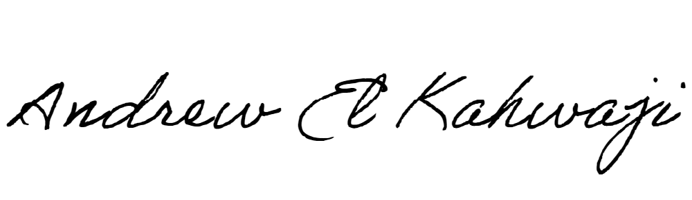

Printed Name _Andrew El Kahwaji_

Date __26/12/2024___

Email __andrew.lifesculptor.coo@gmail.com __

Phone __+961 71 914 378__